Purpose:
To explain tool initial sequence AND to show process chamber etching sequence for software programming.

Initialization sequence:
- Connection with device net device, basic IO system and connection success; AND Turn on vacuum pump ( DO signal)
- Check whether there is any alarm or warning, including but not limited to: main CDA, N2 and vacuum, leak sensor etc...
- Close all the slot valve of chamber.
- Process chamber wafer pickup pin home, up and down (position check and time out function).
- Chuck home, rotate and searching home sensor.
- APC home, T3Bi close then goes to full open, and keeps open if no specify.
- Enable all the heaters (chamber body, chuck, lid, and also piping heaters, expansion chamber, vaporizer heater), and heating each components to target temperature.
Then a dialog is shown to operator “whether to do purging initial or not” If yes goes through the following steps: if no initial is finish and system changing to normal status
- Pumping down the process chamber: first slow then fast, slow/fast change point by configuration. Pumping down low pressure_0.1Torr_(initial config).
- Pumping down the expansion chamber: Pumping down low pressure_0.1Torr_(initial config).

- Purging process chamber: N2 fill to 400Torr, then pumping down to target pressure__0.1Torr_(initial config).
- Purging expansion chamber: N2 fill to 400 Torr, slow N2 fill, then pumping down to target pressure__0.1Torr_(initial config).
- Repeat purging: repeat step j to k for 3 times (initial config) ; and during the purging each chamber should be pumping down separately one by one.
- N2 continue flushing process chamber: Open slow venting N2 valve and open slow pumping valve, N2 purge MFC_1000sccm flushing _30sec, ), then pumping down to target pressure__0.1 Torr_(initial config).
After initial change to normal status

VHF Chamber process sequence
Flow diagram:
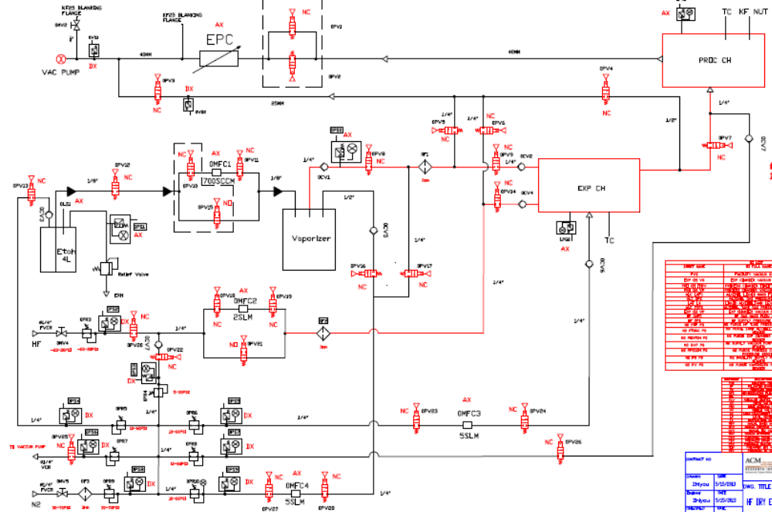
3.1 wafer process normal description

This process sequence mainly consists 3 steps: initialize, processing and post process purging down. Here is a brief description, the detail information please see recipe management part.

Step 1, pumping down and initialization, pumping the HF pipe and process chamber&expansion chamber and N2 pipe, no inlet gas. -→ pumping EtOH pipe, but no EtOH inlet. -→ N2 pure at certain flow and pressure, control by time--→ EtOH moisten, EtOH inlet Open (including carrier N2) at certain flow rate and N2 carrier gas and pressure, control by time, and the parameters set in recipe.

Step 2, processing

Provide EtOH and HF gas into chamber at certain flow rate and chamber pressure, set in recipe. End point by time. → stop HF and EtOH provide, start pumping down chamber, for a certain time after a preset pressure value is reached.

Chuck rotation speed can be set in recipe

Step 3, purge and pumping cycle step.

N2 purging , close HF and EtOH valves, and begin to fill N2 at a certain flow rate into chamber pressure keep at certain pressure, after a certain time. Begins to pumping down (hard pumping no pressure control), after a certain time, finish.

Acknowledge OP that “process finish” whether to unload wafer?

3.2 detail sequence refer to flow diagram

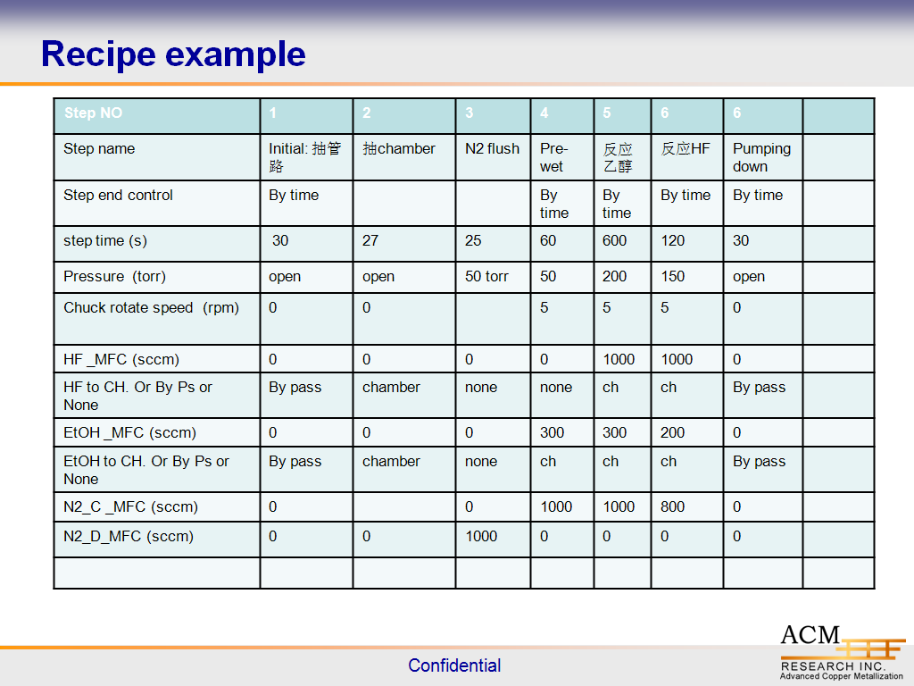
1. After wafers are manually loaded in to chamber, recipe assign and wafer ID record etc…. after a status check (no alarm and warning in system) Then begin hardware action: chamber door close (also named gate valve, slot valve)（OSV1）; MKS APC valve normally is kept at full open position and vacuum pump is on. first open slow pumping valve （OPV1） to 400Torr, then open fast pumping valve （OPV2）and close slow pumping valve(OPV1), pumping down to target pressure （0.1 torr）then keeps the valve open for 5 second then close the valve. ,
2. Pumping down expansion chamber, open OPV3 and OPv4, reach 0.1 Torr, then keeps the valve open for 5 second then close the valve.
3. Begins step 1 in recipe: APC is set to fully open, chuck rotation speed is “0”. HF MFC is 0, EtOH MFC is 0, and related valve is close. Open by pass vacuum isolation valve (OPV3) and HF pipe by pass valve OPV6 and EtOH by pass valve OPV5 for 30s. Then close the valves.
4. Begins step 2 in recipe: APC is set to fully open, chuck rotation speed is “0”. HF MFC is 0, EtOH MFC is 0, and related valve is close. Open chamber fast vacuum OPV1, OPV14 (HF gas) and OPV9(EtOH) and also OPV7, for 27s. Then close the valves.
5. Begins step 3 in recipe: APC is set to pressure control mode pressure target is 50 torr, chuck rotation speed is “0”. HF MFC is 0, EtOH MFC is 0, and related valve is close. Open chamber fast vacuum OPV1, OPV23, OPV24 for N2 purge MFC, N2 purge MFC flow rate set to1000sccm and also OPV7, for 25s. then close the valves
6. Begins step 4 in recipe: APC is set to pressure control mode pressure target is 50 torr, chuck rotation speed is “5” rpm. HF MFC is 0, EtOH MFC is 300sccm, and related valve is open,(OPV13, OPV12, OPV10, OPV11, and make sure OPV15 is close too, which is NO valve). Open carrier N2 MFC at 1000sccm and open related valves (OPv27, OPV28, OPV16. Open vaporizer to provide EtOH to chamber valves OPV8, OPV9 and OPV7, Open chamber fast vacuum OPV1 . until 60s then goes to next step. (这里可能需要判断一下，因为下一步依然有EtOH，因此相关的阀门不需要关闭。但是如果下一步没有EtOH了需要关闭，不过这种情况一般不会出现)。
7. Begins step 5 in recipe: APC is set to pressure control mode pressure target is 200 torr, chuck rotation speed is “5” rpm. HF MFC is 1000sccm， and it is going to chamber, open valves：OPV18， OPV19，OPV20, OPV21（which is also NO valve, turn it off）and OPV14. EtOH MFC is 300sccm, and related valve is open,(OPV13, OPV12, OPV10, OPV11, and make sure OPV15 is close too, which is NO valve). Open carrier N2 MFC at 1000sccm and open related valves (OPv27, OPV28, OPV16. Open vaporizer to provide EtOH to chamber valves OPV8, OPV9 and OPV7, Open chamber fast vacuum OPV1 . until 600s . then goes to next step.

8. Begins step 6 in recipe: APC is set to pressure control mode pressure target is 150 torr, chuck rotation speed is “5” rpm. HF MFC is 1000sccm， and it is going to chamber, open valves：OPV18， OPV19，OPV20, OPV21（which is also NO valve, turn it off）and OPV14. EtOH MFC is 200sccm, and related valve is open,(OPV13, OPV12, OPV10, OPV11, and make sure OPV15 is close too, which is NO valve). Open carrier N2 MFC at 800sccm and open related valves (OPv27, OPV28, OPV16. Open vaporizer to provide EtOH to chamber valves OPV8, OPV9 and OPV7, Open chamber fast vacuum OPV1 . until 120s . then close the related supplying valves and goes to next step.
9. Begins step 7 in recipe: APC is set to fully OPEN, chuck rotate to wafer unload position. Then 0 rpm. HF MFC is 0sccm， and it is going to by pass, close valves：OPV18， OPV19，OPV20, OPV21（which is also NO valve, turn it on）and OPV14 is close too. OPV6 OPEN; EtOH MFC is 0sccm, and related valve is close,(OPV13, OPV12, OPV10, OPV11, and make sure OPV15 is open, which is NO valve). Close carrier N2 MFC at 0sccm and close related valves (OPv27, OPV28, OPV16. Open vaporizer to provide EtOH to bypass valves OPV8, OPV5 and OPV9 is closed. and OPV7 is closed, Open chamber fast vacuum OPV1. And also expansion chamber is pumping down too OPEN OPV4. until 30s . then close the related valves and goes to purge step.
10. Post process purge: this is a post etching purge sequence, the parameters will be set in configuration, 1 according to the set purging N2 flow rate, set Purge_N2 flow rate (e.g 500sccm) (Open OPV23, OPV24 for N2 purge MFC, and also OPV7),then to a certain pressure value, (eg 500 Torr). Stop N2 provide close the valves, stay for a time (e.g 5s) , then pumping down process chamber and expansion chamber to a certain value (0.1Torr, which is in config) and keeps pumping for 5s; a pure-and-pump loop is finish, go loop until reaching the purge time umbers set in config.

11. Acknowledge operator to unload wafers.
Note: This is a sequence without any warning or alarm happened during process. If warning or alarm happened in it, will be added later.
4. HF line purge sequence:
1. OPV20 keeps close, Open OPV22, OPV18 , OPV19, and also keeps OPV21 valve is open too (OPV21 is NO valve). And HF MFC flow set is to 500sccm. Open OPV6 and OPV3. And the purging one cycle is to continue the N2 flowing for 2 minutes (configurable), and then close OPV22 and keeps other valves open, pumping the tubing and evacuate HF for 60s. then a purge cycle is finished.

2.Go and finish all the purging cycles, and the purging times can be configurable too. After that close all the valves, set MFC to 0sccm and keeps OPV21 open.

EtOH line purge sequence:
1, firstly when click the purge button, acknowledge operator to make sure that the alcohol is dumped away.
And double check the level is less than lowest sensorable level.

2. Open OPV13 and OPV12, OPV10 and OPv11, and also keeps OPv15 is open (NO valve), etOH LMF is set to 200sccm; meanwhile open OPv27, OPv28, OPV16 and OPv8, and then goes through OPv5 and OPv3 to vacuum pump. Keeps flushing 2 minutes (configurable),

3. then close OPv12 and Opv13;OPV27 and OPv28 and keeps other valves open to evacuate alcohol and keeps pumping down for 60s.

4, then open OPv12, OPv13, OPv27 and Opv28 for the 2nd cycle of purging until finish all the cycles

5, After that close all the valves and set MFC to 0sccm.

Process chamber purge sequence:

This part please refers to the post process purging sequence. And pay attention that, to pump chamber pressure down, firstly use slow pumping valve then changes to fast pumping valve.

